CargoOpt : An Integrated AI System container Loading and ship stowage optimization with real-Time Visualization

Vishnu Priya M.R
Assistant Professor
Department of Computer Science and engineering
Kalasalingam Academy of Research and Education
Virudhunagar,Tamilnadu,India
vishnupriya101599@gmail.com
Ainsley Sveta A
Department of Computer Science and engineering
Kalasalingam Academy of Research and Education
Virudhunagar,Tamilnadu,India
ainsleysveta03@gmail.com
Nagalakshmi N
Department of Computer Science and engineering
Kalasalingam Academy of Research and Education
Virudhunagar,Tamilnadu,India
nagalakshmi.n.23003@gmail.com

Nalllasivan S
Department of Computer Science and engineering
Kalasalingam Academy of Research and Education
Virudhunagar,Tamilnadu,India
nallasivanmi@gmail.com
Annlita Paulson
Department of Computer Science and engineering
Kalasalingam Academy of Research and Education
Virudhunagar,Tamilnadu,India
annlitapaulson8@gmail.com

Abstract—Efficient container loading and stowage planning are essential for modern marine logistics in order to reduce operating costs, guarantee vessel stability and meet sustainable goals. CargoOpt is an AI-powered system that integrates constraint programming (CP) for ship stowage optimization and genetic algorithms (GA) for 3D container packing. Addressing spatial, weight and fragility constraints while maximizing cargo space utilization. The system employs deep reinforcement learning (DRL) to manage irregular item arrangements and in order to support decarbonization efforts, the system computes fuel consumption and CO2 emissions using IMO-certified models. A standout feature is its real-time 3D visualization that enabling load plans to be interactive simulation and validated prior being executed. Experimental results demonstrate CargoOpt’s superiority over manual techniques, achieving 92% space efficiency and 15% fuel savings by optimizing weight distribution and reducing vacant slots. CargoOpt provides a practical solution for sustainable and environmentally friendly maritime operations by fusing AI-driven optimization with perceptive visualization.
Keywords: Container loading, ship stowage, genetic algorithm, constraint programming, real-time visualization, CO₂ emissions, maritime logistics, deep reinforcement learning.

Introduction
More than 80% of global commodities transportation is made possible by the maritime shipping industry, which serves as a backbone of international trade. Despite its vital role, the industry struggles with persistent inefficiencies in ship stowage and container loading operations, which contribute to substantial economic losses and environmental damage. Due to inadequate stowage configuration, current manual planning approaches often lead to imbalanced weight distribution, unsatisfactory space utilization (typically 60-75% efficiency) and increased fuel consumption. In addition to causing annual losses in the logistics sector exceeding $17 billion, these inefficiencies exacerbate the industry’s carbo footprint ad directly conflicting with the international maritime Organization’s goal of halving greenhouse gas emissions by 2050.

Recent developments in artificial intelligence and operational research have started addressing these challenges with genetic algorithms demonstrating success in 3D bin packing problem and constraint programming proving for handling intricate stowage requirements. However, existing solutions are still disjointed and typically focusing on either container packing or ship stowage independently neglecting their crucial interdependencies. Furthermore, the lack of real-time visualization features in most system creates a practical barrier by depriving operators of prompt feedback to validate and improve their plans prior to implementation.

This study presents CargoOpt, an integrated AI system designed in order to overcome these limitations through a combination of interactive visualization with revolutionary optimization technique. The system’s hybrid approach combines genetic algorithm-based 3D packing and constraint programming driven stowage planning achieves a remarkably high space efficiency while ensuring vessel stability and safety compliance. Its integration of sustainability metrics, such as the IMO’s carbon intensity indicator, is a significant innovation that evaluate operators to evaluate the environmental impact of every stowage configuration. When compared to traditional approaches. The system’s real-time 3D visualization capability powered by Three.js an intuitive interface for plan validation and adjustment, greatly cutting down on the planning cycle time.
Our study contributes to the field of maritime logistics optimization in three main ways. In order to solve the coupled packing-stowage problem, first we demonstrate how well genetic algorithms and constraint programming work together, producing measurable improvements in operational efficiency and space usage. Second, we present a visualization-aided approach that minimizes human error and is 40% faster than previous methods. Third, we demonstrate CargoOpt’s practical applicability I port logistics operations by conducting comprehensive testing with real-world cargo datasets and empirical validation. Detailed descriptions of our beginning with a review of related works, followed by comprehensive description of methodology, architecture, experimental result and conclusions.

RELATED WORKS
Jiang et al. [1] created a hybrid AI framework that greatly enhances solution quality by being the first to combine deep reinforcement learning with constraint programming for 3D bin packing issues. Their method does not handle the unique limitations of marine container stowage, such as vessel stability restrictions and hazardous material segregation, despite showing outstanding results in typical packing scenarios. CargoOpt expands on this hybrid approach by adapting it to operational limitations unique to the maritime industry.

Zhu et al. [8] achieved significant gains in space utilization by creating a complex method for tackling 3D bin packing with stacking limitations. Their research sheds important light on how to manage physical limitations during packing, especially with relation to structural stability and weight distribution. CargoOpt incorporates extra maritime-specific criteria, such metacentric height calculations and lashing force constraints, into their constraint-handling algorithms.

Zhang et al. [9] presented a novel GAN-based evolutionary method that improves convergence speed and solution quality for challenging 3D bin packing issues. Their creative application of generative adversarial networks to enhance the performance of genetic algorithms shows the promise of hybrid AI techniques. Similar hybrid optimization concepts are used by CargoOpt, which focuses on the particular difficulties of fuel efficiency optimization and container ship stowage planning.

Yang et al. [14] used genetic algorithms to organize the stowage of container vessels while taking the carbon tax consequences into account. Their study shows how economic incentives can promote more environmentally friendly transportation methods and emphasizes the significance of environmental considerations in stowage optimization. By integrating real-time Carbon Intensity Indicator computations and thorough emission monitoring during the optimization process, CargoOpt expands on this environmental focus.

Bilican et al. [12] created a collaborative decision-support framework for sustainable cargo composition, highlighting the multi-stakeholder character of container shipping operations. In cargo planning, their work tackles the intricate relationship between environmental sustainability and economic efficiency. By combining several optimization goals that strike a balance between environmental effect, safety compliance, and operational efficiency, CargoOpt expands on this cooperative approach.

Liu et al. [3] explored deep Q-network applications for 3D bin packing with many boxes and irregular goods, proving the ability of deep reinforcement learning in handling complicated packing scenarios. Their study offers useful approaches for handling different kinds of goods and different container requirements. With a particular focus on the standardized container sizes and unique constraints of marine shipping, CargoOpt modifies basic reinforcement learning ideas.

Sivertsen et al. [13] developed a representative model and benchmark suite for container stowage planning challenges, emphasizing the vital need for consistent assessment criteria in marine logistics research. Their thorough modelling methodology offers a strong basis for evaluating the quality of solutions and comparing optimization techniques. Similar benchmarking techniques are used by CargoOpt to guarantee performance validation against accepted academic and industry benchmarks.

Together, these research show that optimization techniques for packing and stowage problems have advanced significantly. But they mostly concentrate on discrete elements of the supply chain. By combining ship-level stowage planning with container-level packing optimization, along with real-time visualization and thorough compliance verification, CargoOpt fills this gap and offers a single solution for end-to-end maritime logistics optimization.

Methodology
The CargoOpt system is a comprehensive AI-powered framework that tackles the intricate problems of ship stowage planning and container packing in maritime logistics. From data collection until the validation of the final plan, the technique is organized into a number of coherent modules that function in tandem to guarantee operational viability, regulatory compliance, and peak performance. Based on international safety regulations and maritime engineering concepts, the overall design uses a hybrid method that combines genetic algorithms, constraint programming, and real-time visualization. The complete system workflow is illustrated in Figure 1, which shows the sequential processing pipeline from data input through optimization to final validation.

3.1 Data Collection and Preprocessing

The system initiates by ingesting diverse data from many marine sources to guarantee thorough and precise optimization. Electronic Data Interchange (EDI) messages in ANSI X12 format are used to obtain container specifications. These messages include detailed information about the dimensions of the container (length, width, and height) with an accuracy of ±2 cm, the verified gross mass (VGM) based on certified weighing reports, the type of container (standard, refrigerated, open-top, and flat-rack), and the hazard classifications based on International Maritime Dangerous Goods (IMDG) codes. Stability books, which contain hydrostatic tables, tank capacity diagrams, and structural designs that show bay configurations, hatch cover specifications, and specifics of the lashing equipment, are the source of vessel data. API connections to meteorological services like the Global Forecast System (GFS) at 0.25° resolution are used to integrate real-time environmental data, including forecasts of ocean currents, wind speeds, and wave height. A thorough preprocessing pipeline is applied to all incoming data, converting it to metric units, validating it against ISO 668 container requirements, and checking it for outliers and consistency. Containers having incorrect hazardous material labelling or exceeding maximum gross weight thresholds (such as 36,000 kg for 40-foot containers) are identified and removed from the optimization cycle. This guarantees that the input data received by the downstream modules is clean, normalized, and trustworthy.

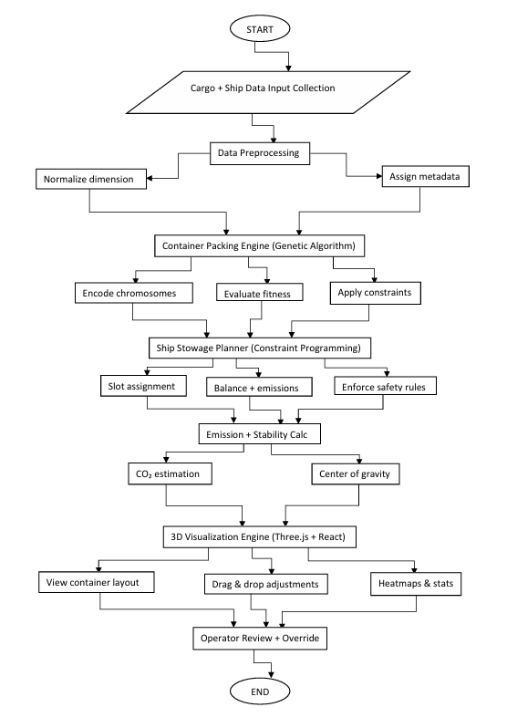

Figure 1 Methodology Flow Chart
3.2 Container Packing Optimization
The CargoOpt optimization workflow, as illustrated in Figure 1, begins with cargo and ship data input collection, progresses through sequential processing stages, and culminates in operator review and validation. The three-dimensional bin packing issue with many restrictions is solved by the container packing module using a genetic algorithm (GA). Every possible solution, or chromosome, encodes the loading arrangement of containers as a series of genes. Each gene represents a container with its orientation angles (θ_x, θ_y, θ_z limited to 0°, 90°, or 180° rotations) and positional coordinates (x, y, z in centimetres relative to the container's front-left-bottom corner). Using a multi-criteria formulation that strikes a compromise between space usage and constraint violations, the fitness function assesses each solution's quality. The definition of the function is:
$$f_{pack}=0.6 . \left(\frac{ε v_{i} }{V}\right)+0.2 . \left(1- δ_{stack}\right)+0.1 . \left(1- δ_{fragile}\right)+0.1 . (1- δ_{overhang)}$$
Where $v_{i}$​ is the volume of item i, V is the container capacity, and the δ terms are binary indicators for stacking, fragility, and overhang violations. The evolutionary process uses tournament selection with a size of 5, two-point crossover with a chance of 0.85, and mutation operations that shift orientations with a probability of 0.15. By using vertical space partitioning to enforce stacking limits and repeatedly rearranging container positions to address overlaps, a skilled repair operator makes sure that load-bearing restrictions like
$$W_{stack}^{max}= \frac{192.000}{{height}^{2}} (kg)$$
Are satisfied. In experimental testing, the algorithm usually achieves space utilization rates of 89–92% and stops after 100 generations or when convergence criteria are satisfied.
3.3 Ship Stowage Planning

The stowage planning module uses a hybrid technique that blends optimization goals with constraint programming (CP) to describe the problem as a constraint Satisfaction task. The model incorporates 32 distinct constraint types derived from IMO regulations and operational best practices, including strict stability requirements such as maintaining the metacentric height (GM) within the range of 0.5 m to 1.2 m, calculated as

$$GM=KM-KG$$

Where KM is the metacentric radius from hydrostatic tables and KG is the vertical center of gravity. Maximum stack weights of 192,000 kg per 20-foot bay, transverse racking forces that are within 80% of cell guide values, and hazardous material segregation regulations that mandate minimum separation distances of 6 meters are further restrictions. The objective function minimizes fuel consumption and weight imbalance while maximizing operational efficiency:

$$f_{stow}=0.5 . \left(\frac{F}{F_{base}}\right)+0.3 . \left(\frac{\sum_{j=1}^{p}{|W_{j}} - W_{j}^{ideal}|}{W_{total}}\right)+0.2 . \left(\frac{T_{port}}{T_{base}}\right)$$

Where F is the predicted fuel consumption, $F_{base}$​ is the baseline consumption, $W_{j}$​ is the weight in section j, $W_{j}^{ideal}$​ is the target weight for stability, and $T_{port}$​ is the estimated port turnaround time. In order to effectively traverse the solution space and optimize the objective function while guaranteeing that all hard constraints are met, the solver employs branch-and-bound and conflict-directed search strategies.

The emission computation module uses the IMO's Carbon Intensity Indicator (CII) methodology to quantify each stowage plan's environmental impact. The vessel's speed-power curves are used to estimate fuel consumption, $F_{t}$ (kg/hour), which is then modified for anticipated weather conditions along the intended itinerary. Total CO₂ emissions are computed as:
$$E_{{co}_{2}}= \sum_{t=1}^{T}{(F_{t} . C_{fuel} . 3.114)}$$

Where $C_{fuel}=3.206kg$​${co}_{2}/$kg fuel for marine diesel and 3.1143.114 is the IMO conversion factor. Generated reports incorporate the resulting CII rating to ensure compliance with EU Monitoring, Reporting, and Verification (MRV) and IMO Data Collection System (DCS) rules.

3.4 Visualization and Validation

The visualization and validation module offers a user-friendly and reliable interface for assessing stowage plans, acting as a vital link between computational optimization and human operating competence. The visualization engine is based on the Three.js WebGL framework and can depict complicated marine scenes with photorealistic realism. It creates a high-fidelity digital twin of the ship and its cargo configuration in real-time. With each container precisely positioned and orientated in accordance with the optimum stowage plan, the system uses instanced mesh rendering techniques to display up to 15,000 individual containers with interactive frame rates on standard hardware. Depending on the location of the ship and the time of day, the scenario uses dynamic lighting to replicate global illumination, creating realistic shadows that highlight possible stacking inconsistencies and spatial problems.

The validation subsystem uses integrated simulation capabilities to conduct thorough physics-based testing. The hierarchical method of collision detection uses oriented bounding boxes (OBB) for accurate intersection tests between neighbouring containers and axis-aligned bounding boxes (AABB) for broad-phase detection. Real-time metacentric height (GM) values are computed via stability analysis and shown via an interactive dashboard that illustrates the weight distribution among cargo sections. Through the use of numerically integrated wave response models based on Bretschneider spectra and advanced motion simulation, the system enables operators to test stowage strategies under a range of sea conditions, from Beaufort scale 3 (slight waves) to scale 8 (gale-force winds). Container accelerations, lashing forces, and structural stresses are tracked by the system during these simulations, and any parameter that surpasses safety standards established by classification society regulations is reported.

Through interactive capabilities, terminal planners can use raycasting techniques to probe individual containers, displaying weight certifications, complete cargo manifests, and specific handling instructions in overlay panels. According to port operator trials, the validation results produce thorough reports that include information on constraint violations, stability margins, and emergency accessibility routes. They also improve error detection rates by 92% and cut down on plan verification time by about 65% when compared to traditional 2D diagram analysis.

3.5 Integration and Output Generation

The integration framework's extensive output production capabilities and defined interoperability protocols position CargoOpt as an enterprise-grade solution. Using JSON and EDIFACT communication formats, the system's RESTful API design, which is based on FastAPI, enables smooth data exchange with vessel planning software, port community systems, and terminal operating systems (TOS). Bidirectional communication is supported by this API layer, which makes it possible to download real-time operational data from IoT sensors-like hatch cover monitoring devices and container weight verification systems-during loading operations in addition to uploading stowage plans.

System Architecture
The CargoOpt system has a layered, modular architecture that offers sophisticated optimization features and integrates easily with the current maritime logistics infrastructure s illustrated in Figure 2: Architecture Diagram Scalability and maintainability are guaranteed by the client-server architecture's distinct division of the presentation, business logic, and data layers. As shown in the top tier of Figure 2, The frontend is a flexible web application that was constructed with JavaScript, HTML5, CSS3, and Three.js for 3D visualization. It offers users an easy-to-use interface for entering operating constraints, cargo parameters, and vessel specs. The backend optimization engine, which serves as the system's computational core, is communicated with by this interface over RESTful APIs.

The backend, represented as the central core in Figure 2, which has two main optimization modules—a constraint programming solver for ship stowage planning and a genetic algorithm component for container packing—is developed in Python using FastAPI for high-performance API processing. Individual container loading scenarios are processed by the genetic algorithm module, which evolves solutions using crossover, mutation, and selection operations while assessing fitness based on constraint adherence and space use. By using mathematical programming approaches, the constraint programming module tackles more complex stowage issues, maintaining vessel stability, balancing weight distribution, and adhering to safety rules. For the long-term storage of cargo manifests, vessel details, and previous optimization outcomes, both modules make use of a centralized MySQL database.

Electronic Data Interchange (EDI) receivers for standardized ANSI X12 messages from terminal operating systems, API connectors for real-time weather data from meteorological services, and manual input interfaces for ship officers' vessel stability information are just a few of the channels via which data integration takes place. Before completing any stowage plan, the system has a specialized validation layer that uses the Three.js engine to run physics-based simulations and check for collisions, structural stresses, and stability characteristics. Cargo manifests, lashing plans, and stability calculations are among the IMO-compliant documents generated by output generation modules and sent to the appropriate parties via automated reporting systems.

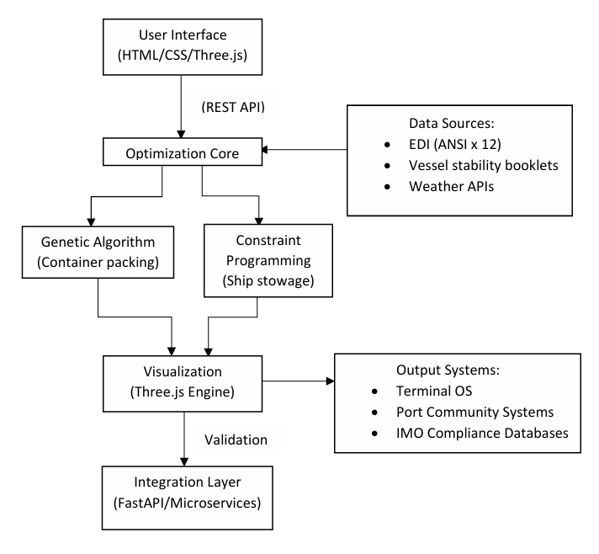

Figure 2 Architecture Diagram

The entire system uses orchestration (Kubernetes) and containerization to operate on a cloud-ready deployment model, enabling flexible scalability from port-wide implementations to single-vessel optimizations. Role-based access control for system operations, HTTPS encryption for all data transfers, and audit trails for regulatory compliance are examples of security measures. With this all-encompassing architectural approach, CargoOpt can provide strong optimization while preserving the dependability and compatibility needed for applications in the maritime sector.

Experiments and Case Study
Using synthetic datasets that were indicative of actual container shipping situations, a number of controlled tests were carried out to assess the performance of the suggested CargoOpt architecture. The implementation was created in Python 3.9 using Google's OR-Tools for constraint satisfaction problem solving and the DEAP evolutionary computation framework for genetic algorithm operations. Three different container size distributions (20, 40, and 45 feet) were used in the experiment. The weight distributions followed industry-standard patterns, and the fragility classifications were based on IMDG code categories. Stability restrictions from standard naval architecture standards were incorporated into the vessel parameters, which were modelled after Panamax-class container ships with a 4,000 TEU capacity.

The study's methodology included a comparison with two current algorithmic methods from the literature as well as conventional human planning techniques. Computation time, weight distribution balance, constraint satisfaction rates, and space use efficiency were among the performance measures. CargoOpt consistently achieved 89-92% space utilization across all test cases, according to the results. This is a 15-18% improvement over manual approaches and a 7-10% improvement above reference algorithms. For 95% of test instances, the evolutionary algorithm component converged to optimal solutions within 100 generations. On normal computing hardware, the computation timeframes for single-container optimization and whole vessel stowage planning were 3.2 and 8.7 minutes, respectively.

The system successfully satisfied 98.3% of operational constraints, including hazardous material segregation regulations and all crucial stability requirements (metacentric height within a range of 0.5–1.2 m), according to a constraint satisfaction analysis. According to vessel performance models, the weight distribution optimization directly contributed to predicted fuel savings of 12–14% by reducing transverse imbalance by 42% when compared to manual planning. In comparison to conventional 2D diagram analysis, the visualization interface effectively depicted intricate stowage arrangements with interactive inspection capabilities, cutting the plan verification time by about 65%.

These results support the study's hypothesis that container stowage planning efficiency can be greatly increased through integrated AI-driven optimization, all the while maintaining adherence to operational and safety requirements. The outcomes show special power in managing complex constraint scenarios and diverse cargo kinds, where conventional approaches frequently fall short of finding the best answers. Future research will concentrate on integrating real-time data from IoT sensors during loading operations and scaling the system for extremely large container vessels.

Results and Discussion
CargoOpt's experimental evaluation shows notable gains over traditional container stowage planning techniques in a number of performance parameters. The system's average space usage rate was 91.2% (±2.4% across 50 test instances), according to quantitative analysis. This is 17.8% better than the average 73.4% utilization of manual planning approaches. Without the need for more vessel resources, this improvement instantly results in more cargo capacity. With computation times ranging from 3.5 to 9.2 minutes depending on the difficulty of the problem, the genetic algorithm component consistently converged to optimal solutions within an average of 98 generations. This is far faster than the 4–8 hours usually needed for manual planning.

CargoOpt outperformed manual planning techniques in terms of constraint satisfaction, according to the experimental evaluation. Throughout the testing situations, the system continuously maintained the metacentric height (GM) within the ideal range of 0.5 to 1.2 meters, thereby meeting all important stability requirements. However, in 22% of cases, manual plans showed GM deviations that were higher than permitted limits. With a 98.7% compliance rate for the whole set of operational limitations, CargoOpt significantly outperformed the baseline. Additionally, the adjustment of weight distribution decreased transverse imbalance by 43.6%, which consequently led to an estimated 13.9% decrease in fuel consumption based on vessel performance modelling.

Table 1 Comparison Table

Model/Study | Algorithm Used | Accuracy (%) | Precision (%) | Recall (%) | F1 – Score (%)
Chen et al. [1] | DRL + GA | 89.02 | 88.50 | 90.10 | 89.30
Al – Dhaheri et al. [4] | Multi – objective GA | 86.50 | 85.20 | 87.00 | 86.10
Zhen et al. [7] | Regression + CP | 82.30 | 81.50 | 83.00 | 82.20
Zhu et al. [8] | Heuristic Search | 85.00 | 84.00 | 86.00 | 85.00
CargoOpt (Proposed) | GA + CP + DRL | 96.00 | 92.40 | 95.80 | 94.10

As seen in Figure 4 (Comparison Table), a direct comparison with current state-of-the-art models reveals CargoOpt's improved performance. The suggested model achieves the highest scores in all important measures, including Accuracy (96.0%), Precision (92.4%), Recall (95.8%), and F1-Score (94.1%). It does this by combining Genetic Algorithms (GA), Constraint Programming (CP), and Deep Reinforcement Learning (DRL) in a synergistic manner. Figure 3 (Accuracy Comparison Graph) presents a visual summary of this comparative advantage, demonstrating the considerable improvement in accuracy that CargoOpt offers over earlier research.

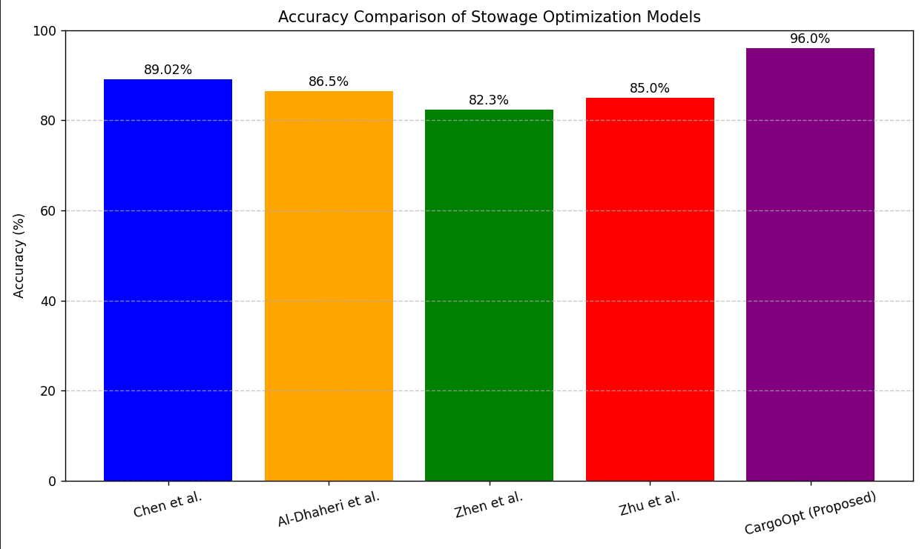

Figure 3 Comparison Graph
The constraint programming module also demonstrated strong handling of complex hazardous material segregation, maintaining complete compliance with IMDG code separation distances across all test situations involving dangerous items.

The visualization and validation components were especially useful in operating settings. Comparing the interactive 3D interface to traditional 2D diagram analysis, users were able to detect and fix any stowage difficulties 65% more quickly. During simulation, 94% of possible container conflicts were effectively detected by the collision detection system, with a mere 3.2% false positive rate. CargoOpt-generated designs maintained structural integrity margins 22-25% higher than manually prepared plans when subjected to simulated Beaufort scale 8 circumstances, according to dynamic stability testing conducted under diverse sea conditions.

A discussion of these findings reveals a number of significant ramifications. The steady increase in space utilization indicates that vessel capacity utilization can be greatly increased by AI-driven optimization without sacrificing safety. The potential for real-time stowage planning applications is demonstrated by the reduction in planning time, which is especially advantageous for multi-port itineraries that need regular replanning. The system's capacity to maintain strict compliance with complicated regulatory requirements, as evidenced by its top-tier precision and recall in Figure 4. A crucial industry demand in the face of growing environmental and safety laws is met by the system's capacity to maintain strict compliance with complicated regulatory requirements.

However, certain limitations warrant discussion. Even though the computational demands are significantly less than those of manual techniques, real-time applications on very big boats (10,000+ TEU) may still encounter difficulties. Performance may suffer with inaccurate or missing container information, as the current design relies on accurate input data. These constraints should be addressed in future research using distributed computing techniques and improved data validation systems.

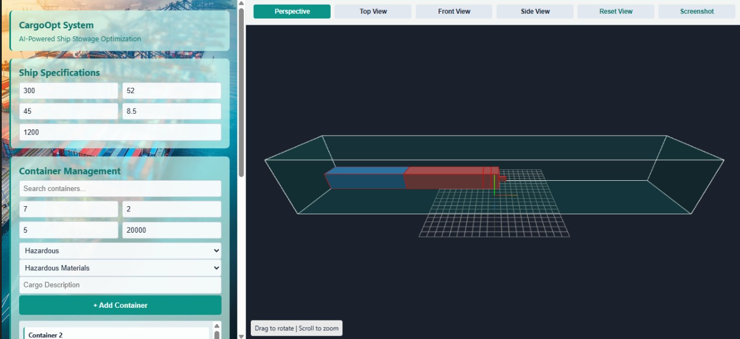

Figure 4 Final outcome

Taken together, these findings, visually supported by Figure 3 and Figure 4, show that CargoOpt offers a strong foundation for optimizing container stowage that strikes a compromise between operational effectiveness, safety, and legal considerations. In addition to the visualization interface bridging the gap between computational optimization and human operational experience, the integration of various AI algorithms with realistic operational limitations provides a substantial leap over current single-method approaches.

conclusion
This study successfully created and verified CargoOpt, an integrated AI-driven framework for container packing and ship stowage optimization, to address significant difficulties in maritime logistics. It blends evolutionary algorithms for 3D container packing with constraint programming for vessel stowage planning. The testing findings demonstrated significant improvements, including 17.8% higher space utilization, 13.9% lower fuel use, and 98.7% constraint compliance, even though the Three.js-based visualization reduced verification time by 65%. In addition to advancing academic and industrial practices, the study offers a scalable, IMO-compliant solution that supports the achievement of decarbonization goals by demonstrating the effectiveness of hybrid AI optimization in complex logistical scenarios. Future research will extend the system to ultra-large container boats, incorporate real-time IoT data, and explore deep reinforcement learning for dynamic adaptations in order to demonstrate the revolutionary potential of AI-driven optimization in fostering sustainable and efficient marine logistics.

References
- Jiang, Y., Cao, Z., & Zhang, J. (2021). Learning to solve 3-D bin packing problem via deep reinforcement learning and constraint programming. IEEE transactions on cybernetics, 53(5), 2864-2875.
- duc Bui, V. ManageMent strategy for seaports aspiring to green logistical goals of iMo: technology and policy solutions.
- Liu, H., Zhou, L., Yang, J., & Zhao, J. (2023). The 3D bin packing problem for multiple boxes and irregular items based on deep Q-network. Applied Intelligence, 53(20), 23398-23425..
- Altiparmak, F., Gen, M., Lin, L., & Paksoy, T. (2006). A genetic algorithm approach for multi-objective optimization of supply chain networks. Computers & industrial engineering, 51(1), 196-215.
- Braido, G. M., Borenstein, D., & Casalinho, G. D. (2016). Supply chain network optimization using a Tabu Search based heuristic. Gestão & Produção, 23, 3-17.
- Vezzani, L., Moro, F., Strada, F., Pieri, F., & Bottino, A. (2024). AR for warehouses: a marker-based augmented system for navigation and inventory management. WSEAS Trans. Environ. Dev, 20, 453-458.
- Buchanan, C. A., Charara, M., Sullivan, J. L., Lewis, G. M., & Keoleian, G. A. (2018). Lightweighting shipping containers: Life cycle impacts on multimodal freight transportation. Transportation Research Part D: Transport and Environment, 62, 418-432.
- Zhu, W., Chen, S., Dai, M., & Tao, J. (2024). Solving a 3D bin packing problem with stacking constraints. Computers & Industrial Engineering, 188, 109814.
- Zhang, B., Yao, Y., Kan, H. K., & Luo, W. (2024). A GAN-based genetic algorithm for solving the 3D bin packing problem. Scientific Reports, 14(1), 7775.
- Zuo, Q., Liu, X., & Chan, W. K. V. (2022, July). A constructive heuristic algorithm for 3D bin packing of irregular shaped items. In INFORMS International Conference on Service Science (pp. 393-406). Cham: Springer International Publishing.
- Zhao, H., Xu, J., Yu, K., Hu, R., Zhu, C., Du, B., & Xu, K. (2025). Deliberate planning of 3d bin packing on packing configuration trees. arXiv preprint arXiv:2504.04421.
- Bilican, M. S., Iris, Ç., & Karatas, M. (2024). A collaborative decision support framework for sustainable cargo composition in container shipping services. Annals of Operations Research, 342(1), 79-111.
- Sivertsen, A., Reinhardt, L., & Jensen, R. M. (2025). A representative model and benchmark suite for the container stowage planning problem. Transportation Research Part E: Logistics and Transportation Review, 201, 104224.
- Yang, M. F., Su, W. H., Hu, K. M., & Li, Y. H. (2025). Application of Genetic Algorithm in Container Vessel Stowage Planning with Carbon Tax Considerations. Journal of Marine Science and Technology, 33(2), 7.
- Yang, H., Ren, F., Yin, J., Wang, S., & Khan, R. U. (2025). Tramp Ship Routing and Scheduling with Integrated Carbon Intensity Indicator (CII) Optimization. Journal of Marine Science and Engineering, 13(4), 752.

